Mrs. Stephanie & Mrs. Freedom’s Newsletter
February 2, 2024
What’s happening in our room?
We played a letter recognition game in my small groups this week and Mrs. Freedom had her create a picture using a 1, 0, and 0 for the 100th day of school. Next week will be about tracking print and the parts of a book.
What’s coming up?
2/12 Cookie Dough Fundraiser
2/13 Papa John’s Night
2/14 Valentines’ Day

Need me?
sconnally@tcjackets.net , Seesaw or 229-225-3908

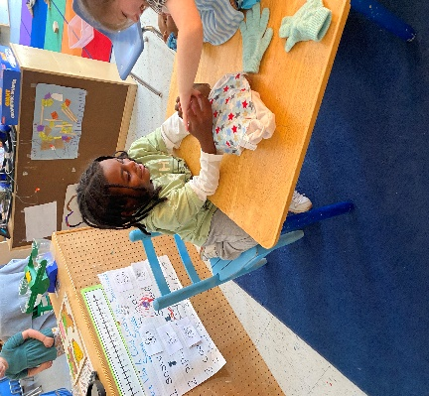
Ar’Treyvious & Tylan playing in the house area.

